Eye-Hand Coordination Experiment

Updated on 3/10/20

**Conditions:**

1. Eye Alone No Feedback
2. Eye Alone Feedback
3. Eye Hand No Feedback
4. Eye Hand Feedback

Eye Alone No Feedback: Subject is instructed only to look at the targets, no hand data is collected. No crosshair cursor is displayed. Subject is instructed to look at the center of the target and no restrictions are placed on them. They are told to look at the targets naturally.

Eye Alone Feedback: Subject is instructed only to look at the targets, no hand data is collected. A crosshair cursor is displayed, connected to the subject’s eye movements. Subject is instructed to direct the cursor to the center of the target. Each subject was given example strategies of looking away from the target or moving their head to correct its position.

Eye Hand No Feedback: Subject is instructed to look and reach for the targets, both eye and hand data are collected. No crosshair cursor is displayed. Subject is instructed to look and reach for the center of the target and no restrictions are placed on them. They are told to look and reach for the targets naturally.

Eye Hand Feedback: Subject is instructed to look and reach for the targets, both eye and hand data are collected. A crosshair cursor is displayed, connected to the subject’s eye movements. Subject is instructed to direct the cursor to the center of the target, while also reaching for the center of the target. Each subject was given example strategies of looking away from the target or moving their head to correct its position.

Prior to the start of the experiment, subjects performed a calibration with the eye-tracking system. A calibration was considered acceptable by the test administrator using the same criteria for each subject.

After calibration, each subject was allowed to train with the Eye Hand Feedback condition for 20 reaches to reduce the learning effects during data collection.

Condition order was randomized for each participant.

**Procedure**

1. Starting target is displayed on the screen.
2. Subject directs their gaze (and finger) to the starting target.
3. After a random amount of time*, a random target appears**.
4. Subject looks (and reaches) to the target.
5. After a random amount of time*, the starting target again appears**.
6. Subject looks (and reaches) back to the starting target.
7. Steps 1-6 are repeated for a total of 50 reaches for each condition (200 total)

*Times are selected randomly between 2s and 5.5s with a linear distribution

**Targets are selected from 1-6 with a linear distribution (Figure 1)

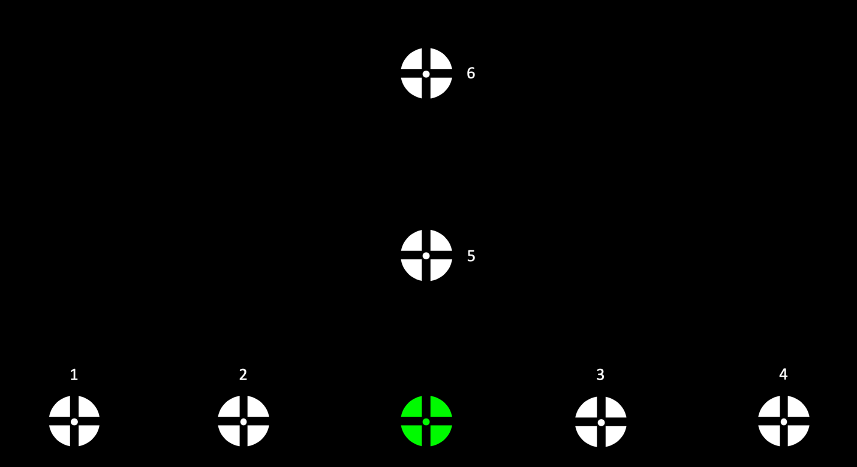

Figure 1: Target number and location

**Post Experiment**

Subjects were asked two questions:

1. What strategies did you employ to correct the position of the cursor (Feedback conditions)?
2. Any other thoughts on the experiment (difficulty, fatigue, etc.)?